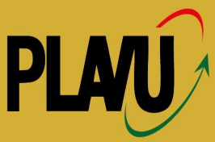 | 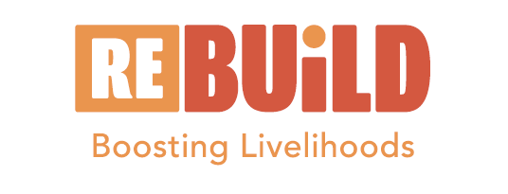 | 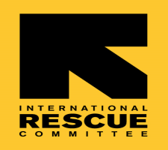

FACILITATE CITY & URBAN COUNCIL LEVEL ROUND TABLE DIALOGUES TO ENSURE GRF COMMITMENTS BENEFIT URBAN REFUGEES & HOST COMMUNITIES

Training Report

Date: 8th May 2024

Pope Paul Memorial Hotel
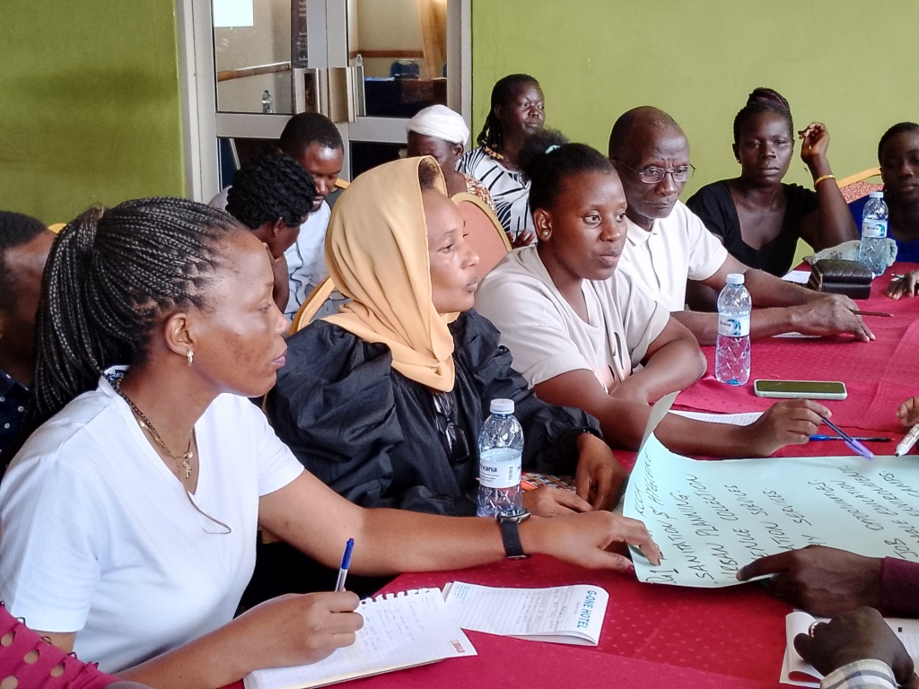

Table of Contents
1.0. Introduction 3
2.0. The Dialogue 3
2.1. Objectives of the Dialogue 3
2.2. Methodology 4
2.3. Participants of the Dialogue 4
3.0. Opening Session 4
4.0. Session 1: Plenary Discussion on City Pledges 4
5.0. Session 2: Breakout Sessions 5
6.0. Session 3: Plenary Session and Wrap-Up 6
Attendance list 8

Introduction

Platform for Vendors in Uganda (PLAVU) is a National Federation of urban poor informal workers. The organisation is part of several partners implementing an urban refugee development programme funded by IKEA Foundation. The programme is Refugees in East Africa: Boosting Urban Innovations for Livelihoods Development (Re: Build). PLAVU focuses on advocacy, promoting social cohesion among urban refugees and host communities; promotion of practices that contribute towards achieving self-reliance; and building linkages between hosts and refugees and business associations. The programme is implemented in all the divisions of Kampala.

According to UNHCR; August 2023, currently Uganda hosts 1,568,237 refugees and asylum seekers (807,857 females, 760,380 males). Kampala city alone is hosting 121,499 refugees and asylum seekers. 55,884 and 65,615 of these were females and males respectively. This increase is due to fragile security situation and the harsh climate conditions in the region.
While in cities, most refugees are involved in the largest production informal sector for survival. Urban refugees face multiple challenges including inadequate access to financial services, government development programmes and the partial social cohesion with host communities making it more challenging.

The Dialogue

Stakeholders convened at the Pope Paul Memorial Hotel in Kampala for a pivotal City & Urban Council Level Round Table Dialogue aimed at aligning Kampala's municipal policies with commitments outlined at the Global Refugee Forum (GRF). The dialogue focused on ensuring these commitments effectively benefit urban refugees and host communities within Kampala. With participation from city officials, representatives of urban divisions, NGOs, and international stakeholders, the training facilitated collaboration, defined actionable strategies, and set the stage for inclusive urban development initiatives. This report encapsulates the key discussions, outcomes, and next steps emerged from the dialogue, highlighting a shared commitment to enhancing refugee integration and urban development within Kampala.

Objectives of the Dialogue

- Raise awareness among stakeholders about GRF commitments and city pledges.
- Foster collaboration and consensus among city and urban council stakeholders.
- Develop actionable strategies for implementing city pledges to benefit urban refugees and host communities.

Methodology

The dialogue embraced participatory methods, including group discussions, plenary sessions, and brainstorming, enabling all participants to actively discuss and share their thoughts, views, and concerns.

Participants of the Dialogue

The meeting was attended by 30 participants (21 females and 9 males). Refugee community was represented by 18 participants (11 females and 7 males). These refugees were from Somalia (3), Sudan (3), Congo (6), Burundi (2) and Rwanda (4). All the participants were representatives of community based organisations. Each of these participant represented 3- 4 groups. In fact each was supposed to work with these groups. The participants’ representation is shown in the summary table that follows:

Nationality | Female | Male | Total
Burundians | 1 | 1 | 2
Congolese | 5 | 1 | 6
Rwandese | 3 | 1 | 4
Somali | 0 | 3 | 3
Sudanese | 2 | 1 | 3
Ugandans | 10 | 2 | 12
 | 21 | 9 | 30

Opening Session

The event commenced with an overview of objectives. Participants were introduced, including city officials, NGO representatives, and refugee community leaders. The agenda and objectives for the day were presented by the PLAVU Programme Manager.

Session 1: Plenary Discussion on City Pledges
PLAVU Executive Director presented city pledges related to refugee integration. Participants engaged in a Q&A session to clarify commitments and explore potential synergies.

This session enhanced understanding of city pledges and alignment with GRF commitments. City representatives and the event facilitator led the discussion.

Session 2: Breakout Sessions

During the round table dialogue, participants engaged in focused discussions within smaller groups, each dedicated to key thematic areas: institutionalizing refugee access, enhancing integration, and promoting socio-economic solutions. These sessions were crucial in identifying actionable strategies tailored to the local context. As one participant noted,

"The discussions allowed us to pinpoint specific ways to integrate refugee needs into our city's budgeting and planning cycles, ensuring their voices are heard."

Facilitators played a pivotal role in guiding these deliberations, ensuring that strategies were not only innovative but also feasible within Kampala's administrative framework.
Throughout the breakout sessions, facilitators and group leaders meticulously documented the strategies and action plans emerging from each thematic area. This systematic approach was highlighted by another participant who remarked,

"It was inspiring to see how diverse stakeholders came together to develop concrete plans for improving refugee access to essential services and fostering greater socio-economic opportunities."

The involvement of urban refugees in division-level budget conferences emerged as a particularly promising initiative, underscoring the dialogue's commitment to inclusive decision-making and sustainable urban development.
A third participant emphasized,

"The dialogue provided a platform for open exchange, where we could address challenges and explore opportunities collaboratively. This collaborative approach ensures that our efforts are not only impactful but also sustainable, benefiting both refugees and host communities."

This sentiment reflects the dialogue's success in fostering consensus and outlining practical steps towards realizing shared goals of integration and empowerment in urban settings.

Session 3: Plenary Session and Wrap-Up

Groups reconvened to report back on breakout session outcomes. Key stakeholders agreed on next steps and commitments to advance implementation of city pledges, including commitments from urban city divisions to involve urban refugees in attending division-level budget conferences. Closing remarks highlighted contributions and encouraged continued collaboration. Group leaders and the event facilitator consolidated action points and commitments.

During the round table dialogue, one group proposed the establishment of dedicated departments within city administration for refugee liaison and coordination. They emphasized the importance of integrating policies across city departments to ensure equitable access to essential services for refugees. This initiative aims to enhance refugee participation in city planning and decision-making processes, fostering social integration and community engagement (Round Table Dialogue Summary, May 2024).

Another group focused on fostering social cohesion through comprehensive integration strategies. They suggested conducting baseline surveys to better understand the demographics and needs of refugee populations across urban divisions. Additionally, they advocated for the establishment of division-level monitoring mechanisms to track progress and address challenges in service delivery to refugees. These initiatives are critical in promoting inclusive communities and ensuring effective support for refugees in Kampala (Round Table Dialogue Summary, May 2024).

Furthermore, a third group outlined strategies for promoting socio-economic solutions for refugees. They proposed developing training programs for local officials to enhance their capacity in supporting refugee integration efforts. Additionally, they emphasized the importance of forging partnerships with NGOs, international organizations, and the private sector to provide resources and expertise for refugee-focused initiatives. Advocating for policy reforms at local and national levels to remove barriers hindering refugee access to socio-economic opportunities was also a key focus of their action plan (Round Table Dialogue Summary, May 2024).

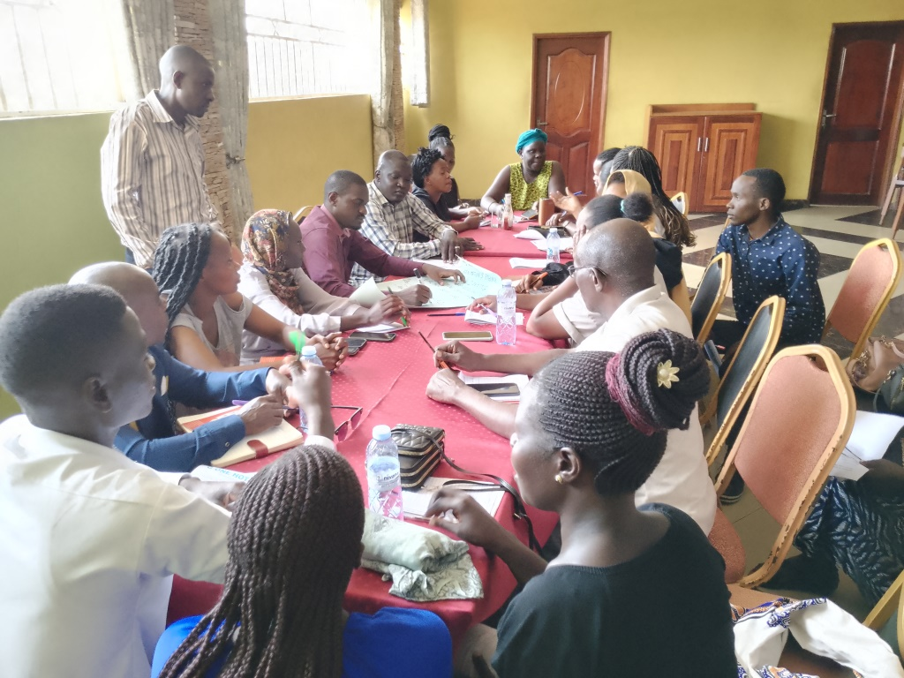
Group members comprising of Makindye and Nakawa representatives

Next Steps:
- Documentation: Compile detailed minutes and outcomes from discussions, including action points and responsibilities, to create a comprehensive record of agreements and decisions made during the dialogues.
- Reporting: Share the comprehensive report with participants for feedback and endorsement to ensure all stakeholders are aligned and supportive of the agreed-upon strategies.
- Implementation Planning: Initiate follow-up meetings to develop detailed implementation plans based on agreed-upon strategies and timelines, ensuring that actions are carried out effectively and monitored for progress.

Conclusion:
The round table dialogues successfully facilitated a collaborative environment where stakeholders engaged constructively to align city policies with GRF commitments for the benefit of urban refugees and host communities. Moving forward, continued coordination and commitment, including the participation of urban refugees in division-level budget conferences, will be crucial to achieving sustainable outcomes.

Attendance list

No | Name | Sex | Group Name | Division | Nationality | Contacts
1 | Habimana Gerald | M | Rema Group 49 Members | Lubaga | Burundian | 0770 943449
2 | Kavitesi Florence | F | Women Building Nation Refugee Group | Lubaga | Burundian | 0757 433573
3 | Samantha Samba | F | Bright Women | Makindye | Congo | 0709 689560
4 | Clovis Mugenyi | M | Angels Fashion devt Group | Makindye | Congo | 0761 140275
5 | Vestarade Asmahan | F | Light Social Innitiative | Makindye | Congo | 0702 089571
6 | Bamulange Odile | F | La Grace Group | Lubaga | Congo | 0781 330497
7 | Igabire Prossy | F | Namugoona Youth bags & leater crafts | Lubaga | Congo | 0777 605341
8 | Uwineza Sulaina | F | Faith Development Group | Lubaga | Congo | 0774 209801
9 | Agnes Mulamugena | F | Agape Refugee Foundation | Lubaga | Rwanda | 0701 885864
10 | Appolon Mukakamali | F | Refugee Womens Development Group | Lubaga | Rwanda | 0785 463322
11 | Uwineza Saddick | F | Charity Development Group | Lubaga | Rwanda | 0708 606309
12 | Kabalega Andrew | M | Urunana Community Savings Group | Lubaga | Rwanda | 0780 153448
13 | Nayma Awale Hisi | M | Muno Nuir Saving Group | Central | Somali | 0776 629056
14 | Mohamed Hassan Abdalkadir | M | Somali Community Association | Central | Somali | 0758 526800
15 | Dhaah Ali Hashi | M | Aidar Refugee Group | Central | Somali | 0744 507177
16 | Fatuma Njundi Sulaina | F | Blue Nile youth Development Group | Makindye | Sudanese | 0789 939209
17 | Hajir Elbadani | M | Mantairs sudanese community in K'la | Makindye | Sudanese | 0773 366677
18 | Adam Ahmed Abdallah | F | Makerere | Central | Sudanese | 0774 303869
19 | Anek Agnes Odong | F | Kabalagala Kiwaffu Women Devt Group | Makindye | Ugandan | 0789 390585
20 | Katutu Betty | F | Mukama wa Buyinza Womens Group | Makindye | Ugandan | 0776 585096
21 | Nanyango Sarah | F | Kwagalana Devt Group | Makindye | Ugandan | 0704 660597
22 | kaddu Justine | F | Hope Family Savings Group | Central | Ugandan | 0706 700682
23 | Mawilak Gloria | F | Naguru women savings Group | Nakawa | Ugandan | 0766 156680
24 | Babirye Rose | F | Tuyinza Saving Sacco | Central | Ugandan | 0753 482184
25 | Mbabazi Winnie | F | Toto Business Group | Lubaga | Ugandan | 0701 226099
26 | Kakooza Prossy | F | Kabalagala Critical Thonkers | Makindye | Ugandan | 0772 949254
27 | Nakagwe Agnes Mirembe | F | Twezimbe Savings Gropu | Makindye | Ugandan | 0760 383229
28 | Mukalazi Abdulrahman | F | Right Hand of Uganda devt Group | Makindye | Ugandan | 0757 101933
29 | Okuku Frank | M | Kabalagala Critical Thonkers | Makindye | Ugandan | 0773 041419
30 | Vincent Sseguya | M | Nyago Local Council Leader | Makindye | Ugandan | 0754185585

