 | 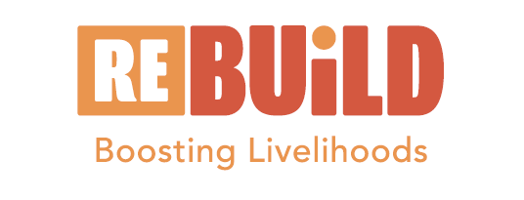 | 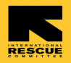

TRAINING IN REFUGEE RIGHTS & RESPONSIBILITIES AND CAPACITY SHARING WITH REBUILD PARTNERS

KAWEMPE DIVISION
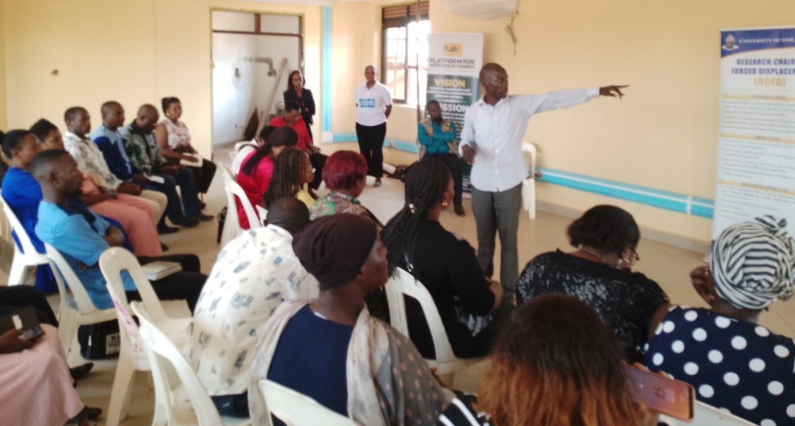

28th May 2024 at Kawempe Division Headquarters

Table of Contents
1.0. Introduction 2
1.1. Objective of the activity 2
1.2. Methodology 3
1.3. Challenges 3
1.4. Participants 3
1.5. Opening Session 4
2.0. How we integrate Refugees in social Services? 5
3.0. What challenges do leaders face to deliver services? 7
4.0. Closing remarks 8
Annex 1: Attendance List 9
Annex 2: The Day’s Programme 10

Introduction

Kampala District continues to host Urban Refugees and Asylum Seekers comprising about 15 different nationalities. The majority hailing from Democratic Republic of Congo (DRC), Somalia; Eritrea; South Sudan; Burundi Rwanda; Ethiopia and Sudan. Women and children make over 68% of the urban refugee population; Children (0-17 years) and the elderly (60+ years) make up to 44% of the refugee and asylum seeker population. 44% of the urban refugee population is either unemployed or students while 29% of the working age (18- 59yrs) self-identifies as unemployed.

In Kampala, the majority of refugees typically reside in low income congested slum areas with poor sanitation, shanty and or makeshift accommodation. Their economic activities includes working at bars, hawking, survival sex, trading in drugs, activities that attract criminal due to their livelihood challenges hence exposure to heightened protection risks. According to the UNHCR Uganda Livelihoods Socio-Economic Assessment report (2017), 30.1 percent of urban refugees in Kampala were not engaged in any economic activity, 27.8 percent were participating in business, 6.3 percent were salaried employees, 16.8 percent were in the artisan sector and 13.9 percent were employed as casual laborers.

Platform for Vendors in Uganda (PLAVU) is a National Federation of urban poor informal workers. The organisation is part of several partners implementing an urban refugee development programme funded by IKEA Foundation. The programme is Refugees in East Africa: Boosting Urban Innovations for Livelihoods Development (Re: Build). PLAVU focuses on advocacy, promoting social cohesion among urban refugees and host communities; promotion of practices that contribute towards achieving self-reliance; and building linkages between hosts and refugees and business associations.
For the last 2 years, Re-Build programme was being implemented in only 3 divisions of Kampala (Rubaga, Kampala Central and Makinye). This was because (according to OPM data) the area was the hotspot for refugees. However, having realized that the need is increasingly felt in other divisions of the city, Re-Build programme was expanded to the two other divisions of Kawempe and Nakawa.

A governance; Refugee rights and responsibilities training was organised for Rubaga, Makindye and Kampala central divisions in 2023. This training therefore meant to benefit partners in Kawempe and Nakawa divisions.

Objective of the activity

Overall Objective

The overall objective of the training was to “create awareness on refugee rights and responsibilities to representatives of Local Councils, refugee led Organisation, host community members and to understand potential ways for integrating refugees in existing services”.

Specific Objectives

- Train local leaders and other Re: Build partners in refugee policies, rights and responsibilities for them to better address urban refugee’s need and self-reliance,
- Establish a strong network with local leaders to champion the urban refugee cause and to support Re: Build’s community advocacy efforts,
- Generate feedback from the local leaders and service providers on challenges encountered in delivering services to urban refugees,
- Identify potential ways for integrating urban refugees in existing services

Methodology

The facilitators of this training used participatory methods to involve all participants. The specific methods used included brainstorming, presentations by the facilitator and plenary discussions.

Challenges
During the planned activity, there were so many other official meetings at the division. This meant delays in accessing the training venue. Because of that, some of the set activities was skipped.

Participants

In Kawempe division, 49 persons (24 females and 25 males) attended the training. Refugees were represented by 21 persons (12 females and 9 males). These were drawn from the refugee communities of Burundi, Congo, Sudan and South Sudan. KCCA was represented by 5 officials from CDO, Gender offices and elected representatives. The tables that follow shows the detailed representation per division.

Category of Participants | Females | Males | Sub-total
Refugees
Burundians | 1 | 1 | 2
Congolese | 6 | 7 | 13
Sudanese | 2 | 1 | 3
South Sudanese | 3 | 0 | 3
Sub-total | 12 | 9 | 21
Tanzanians | 1 | 0 | 1
Ugandans | 11 | 16 | 27
Sub-Total | 12 | 16 | 28
Total | 24 | 25 | 49

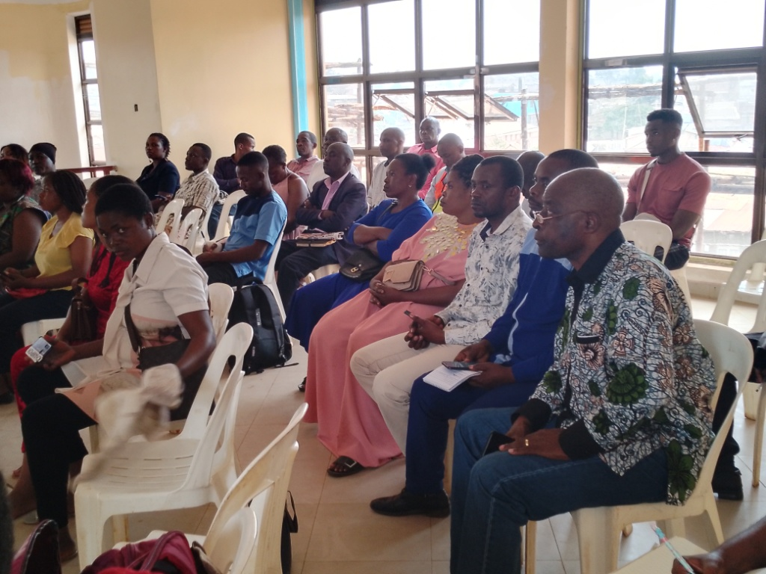
Participants listening attentively during the training

Opening Session

The training and sharing session started with prayers which was led by a volunteer. Thereafter the participants introduced themselves.
The Programs Manager of PLAVU; Bruno Onzima welcomed participants on behalf of PLAVU. He shared an overview of PLAVU and REBUILD Programme. He said that PLAVU (Platform for Vendors in Uganda) advocates for the rights of the vendors especially the informal workers. Apparently, vendors can be annoying and therefore need to work together with the City authority in order to benefit from their innovations.
PLAVU was founded in 2013 and has worked before with market vendors of Nakawa. PLAVU has partnered with IRC to implement REBUILD (Refugees in East Africa, Boosting Urban Innovations for Livelihood Development.

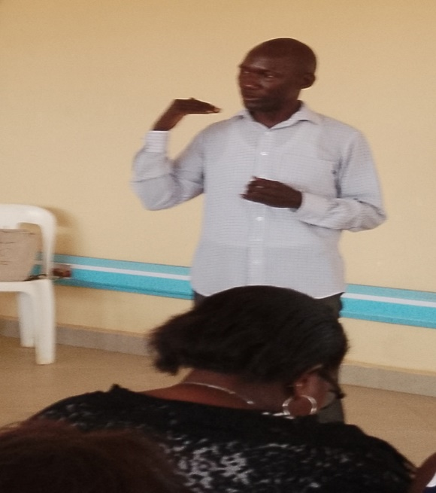
Bruno PM of PLAVU

Bruno said that refugees are not confined in settlements because of Uganda’s policy of ‘free movement’. Refugees find themselves in cities as a way of survival. While in camps, refugees are supported and given land to undertake some cultivation. But in urban city, government is not actively supporting. Using hotspots mapping from OPM, IRC and PLAVU opted to work with the 3 division of Rubaga, Makindye and Kampala Central which had the most refugees. Today the need is felt in other areas, therefore the programme expanded to Nakawa and Kawempe divisions.
Re-Build is implemented in 3 pillars:

- Service delivery
- Research and evidence building
- Influence and Adoption

In her opening remarks, the CDO of Kawempe welcomed participants. She mentioned that her office is open to everyone including refugees. However, most of the refugees keep away. “But now that you have encouraged me, I will identify the refugee hotspots in Kawempe and effectively work with them” she said.

Prof. Opportune Kweka from the University of Dares Salam shared information concerning the outreach, scholarship and supporting research on displacements.

How we integrate Refugees in social Services?

Mr. Simon Ssemuwemba (IRC staff) asked the participant to respond to the question; how can we integrate refugees in existing services? These were their responses:

Refugee Sector Development | Key Actions
- Employment and Skilling |  | - Promotion of innovation  - Creating job opportunities  - Education upgrading to allow competitiveness  - Advocate for non-discriminative laws- say no to discrimination  - Needs assessment and skilling centres should open up to refugees
- Legal Services |  | - Provide free legal services11:00- 12:30 pm Sensitize refugees about their rights and responsibilities  - Support community registration/residential registration for urban refugees  - Advocate for equality ad equity before the law
- Health Services |  | - Establish refugee focal persons in all health facilities to handle refugee issues  - Advocate for supplementary budgets for refugees  - Sensitize health officer on how to handle refugees  - Provide medical referral cards to refugees
- Education Services |  | - Provide bursary and scholarship to urban refugees  - Support mentoring and career guidance to refugee students  - Provide meals to urban refugee students  - Encourage refugees to attend adult education programmes
- Finance and Business Services |  | - Support refugee groups with financial services  - Support financial literacy and inclusion programmes  - Assist group registration
- Housing and Shelter Services |  | - Engage government to set rent standards  - Sensitize landlords to provide equal opportunities to urban refugees and nationals  - Provide legal support to refugees over rent challenges  - Support in development of tenant protection laws
- Recreation and Sports |  | - Promote talent through construction and establishment of sports facilities  - Inclusion of refugees in sports clubs and tournaments  - Promote refugee talents

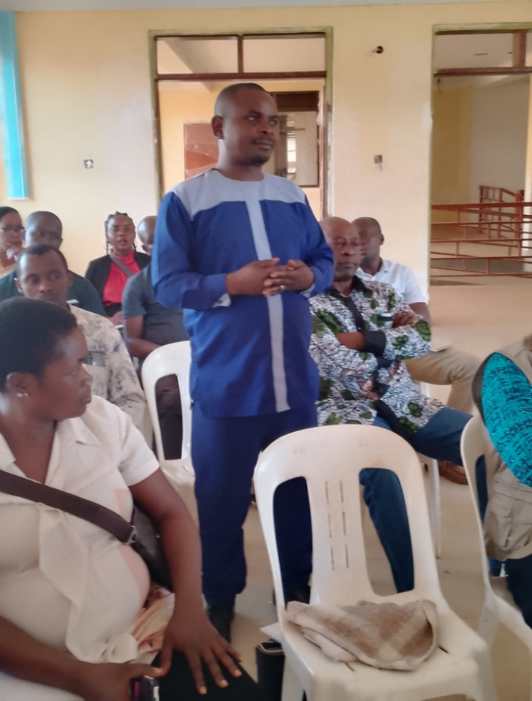

What challenges do leaders face to deliver services?

Simon finally asked the participants to share the challenges they face in the process of delivering services to urban refugees. These are listed below:

According to the Division local leaders….:

- “Refugees are not cooperative. They tend to shy away from the service providers. They usually undermine themselves considering themselves as secondly citizens” reported the CDO,
- Many foreigners are asylum seekers and most lack identification and because of that they hide away from service providers,
- Most urban refugees use brokers or middlemen and never come out openly,
- Urban refugees are not united and never speak in unison.

Information from the Local Council 1 representatives (LC I) revealed that…:

- Language barrier is a major bottleneck for serving refugees,
- Some refugees are arrogant aggressive and poorly behaved

Closing remarks

James Okelo (CDO office Assistant), asked participants to take note of their lessons picked from the day’s session. He noted that “we learn every day. We should know that refugees can harmoniously live among us. We need mindset change. Refugees should consider themselves part of the communities they live in. Be confident and demand for the services and keep yourselves informed at all times”. He thanked everyone for attending the training.

In her closing words, the CDO shared some of the development programmes available for vulnerable host community members and urban refugees. These include:

- Birth and Death registration
- Registration of CBOs and RLOs
- Parish Development Model (PDM) but this is only for nationals with National Identification Number (NIN)
- Skilling programs
- Sexual reproductive Services
- Gender Based Violence Programming
- Program for Disabled Persons
- Social Assistance Grant for Empowerment (SAGE)
- Functional Adult Literacy Program (FALP)

Professor Opportune Kweka, thanked participants for attending this capacity sharing session in good numbers and for their contributions. She talked about the research- displacement conducted by Dar Salam University and the scholarship support provided to students in Eastern Africa. She called on refugees to apply and utilize that given education opportunity.

Annex 1: Attendance List
No | Name | Sex | Designation | Organisation | Nationality | Contact
1 | Kezakimana Brenda | F | Refugee | Group leader | Burundi | 0771 897738
2 | Gonda Musa Junior | M | youth leader | winners | Burundi | 0772 473824
3 | Isse Vindu Kasereka | M | Secretary | FAMM Victors | Congo | 0773 939499
4 | Safari Kanane | M | Refugee | Cong | Congo | 0779 417027
5 | Janvier Mujhire | M | Refugee | Congolese Leader | Congo | 0763 154938
6 | Fredrick Nakarutimere | M | Refugee | Congolese Leader | Congo | 0758 990224
7 | Tumusifu Mulemesha | F | Refugee | Group leader | Congo | 0772 504980
8 | Joyce Mbambu | F | Refugee | Group leader | Congo | 0785 668064
9 | Maniwa Mupenda Agutine | M | Refugee | Congolese Leader | Congo | 0750 903025
10 | Saidi Jonathan Fama | M | Member | Supu daddy | Congo | 0761 061119
11 | Biwa Germaine | F | Member | Congolese Leader | Congo | 0706 881522
12 | Sabila Mastola | F | Member | Congolese Leader | Congo | 0703 765412
13 | Julien Mastola | F | Leader CRCU | Congolese Leader | Congo | 0757 970663  0757 970569
14 | Kajuris Chihimbi | F | Member | Congolese Leader | Congo | 0753 77724
15 | Kavira samija | F | Member | Congolese Leader | Congo | 07716 15466
16 | Francis Banda | M | Refugee | Group leader | Sudanese | 0781 147283
17 | Bako Zautini | F | Refugee | Group leader | Sudanese | 0776 582463
18 | Photo Emilly | F | USSURC Admin | s.sudan | Sudanese
19 | Adia Rose Doreen | F | Woman Advisor | South Sudan | S. Sudan | 0773 601595
20 | Apiyi Rose | F | Information | s.sudan | S. Sudan | 0760 665681
21 | Aber Jackline Keny | F | C/PERSON | Winners | S. Sudan | 0771 304440
22 | Opportune Kweka | F | Professor | University of Dares Salam | Tanazania | 0763 677254
23 | Ssemuweba Simon | M | Advocate | IRC | Ugandan | 0754 562946
24 | Bbosa Aminah | F | V. Chairperson | Mugowa | Ugandan | 0752 673863
25 | ANDREW kawooya Ssebunya | M | MEAL | PLAVU | Ugandan | 0772 626186
26 | Kabahumba Yusta | F | Advocacy | PLAVU | Ugandan | 0773 365616
27 | okello james | M | Gender Officer | PLAVU | Ugandan | 0774 567157
28 | Namono Rosemary | F | Ass. CLO | PLAVU | Ugandan | 0777 537292
29 | Onzimz Bruno | M | PM | PLAVU | Ugandan | 0775 860302
30 | Nabirye Justine | F | Office admin | PLAVU | Ugandan | 0779 844625
31 | Omuya ROBERT | M | CLO | PLAVU | Ugandan | 0789 430022
32 | NYAKAKE Priscilla | F | ACDO | KCCA | Ugandan
33 | Ssebulime Abdullatif | M | C/PERSON | St. Francis | Ugandan | 0702 737009
34 | Ssemere Ronald | M | C/person | Bugalani | Ugandan | 0752 612625
35 | Zziwa Simon | M | C/PERSON | Kiyindi Zone | Ugandan | 0702 358178
36 | Nalubowa Marion | F | C/PERSON | Katalebwa 2 | Ugandan | 0704 344268
37 | Ssebwato Godfrey | M | C/PERSON | Mukalazi | Ugandan | 0700 908597
38 | Mutaasa Kigongo | M | C/PERSON | Keti-Falawo | Ugandan | 0754 257747
39 | Ssali Stephen | M | C/PERSON | Kiiza | Ugandan | 0751 835111
40 | Mudumba Moses | M | Secretary | Lufula | Ugandan | 0752 311076
41 | Hassan Muzani | M | C/PERSON | Lufula | Ugandan | 0753 201272
42 | Kimuli Vanessa | F | Gender Officer | KCCA | Ugandan | 0787 317999
43 | Mangeni Peter | M | Member | Kawempe | Ugandan | 0781 500645
44 | Namukasa Jane. N | F | C/PERSON | Kazo angole c | Ugandan | 0702 516806
45 | Kikuwa Robert Dsaul | M | C/PERSON | Logoba | Ugandan | 0704 144789
46 | Ssimbwa William | M | C/PERSON | Lufula | Ugandan | 0750 594129
47 | Esther Kyazike Ssebaduka | F | C/person Gender | KCCA | Ugandan | 0773 518013
48 | Nakawesi Betty | F | Gender Officer | KCCA | Ugandan | 0782 720819
49 | Nassali Sharifah | F | CDO | KCCA | Ugandan | 0782 431479

Annex 2: The Day’s Programme

Time Slot | Activity | Expected Output | Lead Person
9:00- 9:30am | Participant registration  Introduction  Opening remarks | Participants should be identified by category and name by the end of the session | REBUILD  PLAVU
SESSION 1: URBAN REFUGEES AND THE LAW
9:30 – 10:00am | Understanding the laws governing urban refugees | Participants will appreciate governing laws for Uganda | REBUILD
10:00- 10:30 am | HEALTH BREAK |  | Service Provider
SESSION 2: HOW CAN WE INCORPORATE URBAN REFUGEES IN OUR SERVICES?
10:30- 11:00am | Sharing ideas on how to incorporate urban refugees in different services | Appreciate different ways in which stakeholders can incorporate urban refugees in the services | REBUILD
SESSION 3: CHALLENGES FACED WHEN EXTENDING SERVICES TO URBAN REFUGEES
11:00- 12:30 pm | Sharing lived experiences when extending services to urban refugees | Challenges faced by stakeholders when extending services to urban refugees | STAKEHOLDERS
12:30- 13:00 pm | Final Remarks, Lunch and Departure |  | REBUILD  SERVICE PROVIDER

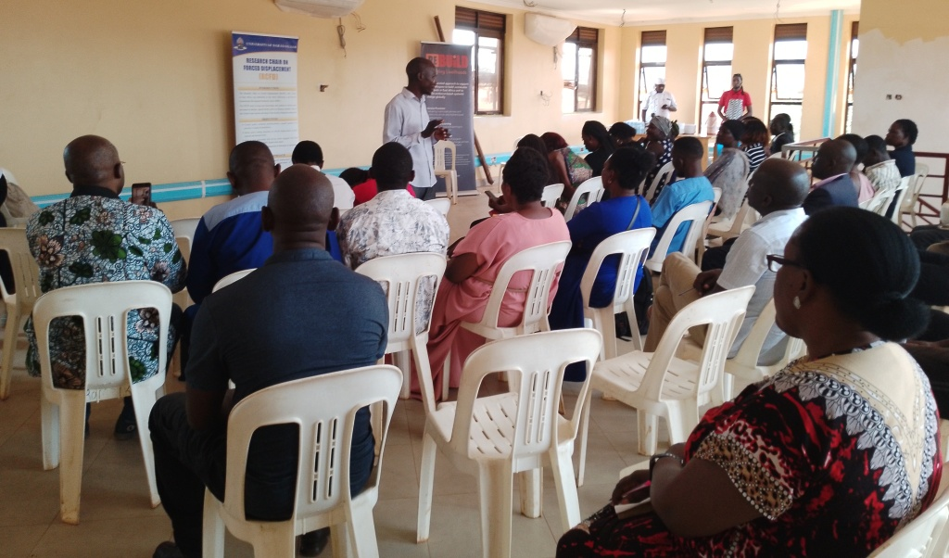

Prepared by ____________________ Signature ___________ Date __________

Approved by ___________________ Signature ___________ Date __________

