 | 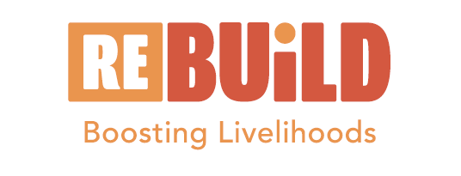 | 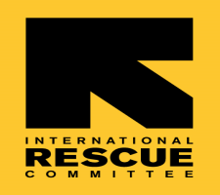

Governance & Advocacy training for CPFs: Enhancing their capacities to better play their RLOs/CBOs mandates

Training Report

Wednesday 20th March 2024
Held At G-One Hotel
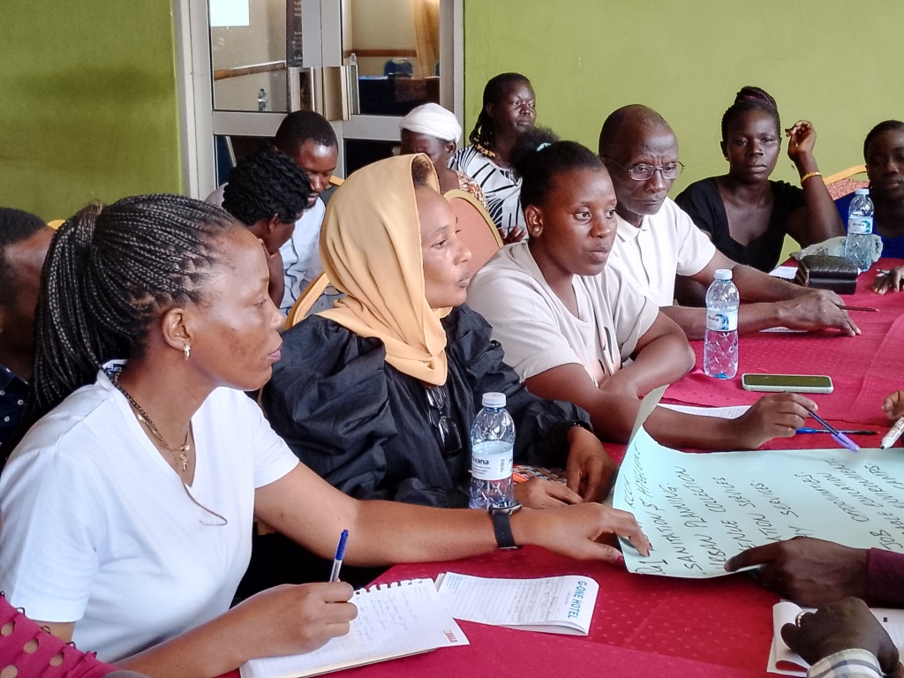

Table of Contents
1.0. Introduction 3
2.0. The CPFs training 3
2.1. Objectives of the training 3
2.2. Methodology 4
2.3. Participants of the training 4
3.0. Opening Session 4
4.0. Session 1: Deepening understanding of the groups, organisations we belong in 5
5.0. Session 2: Understanding the Concept Community Based Organisations/Associations 5
6.0. Session 3: Understanding Organisational Structures, Systems and functions of KCCA/Duties of citizens 7
7.0. Session 4: Understanding the concept Advocacy 13
8.0. Session 5: Action planning 13
Attendance list 16

Introduction

Platform for Vendors in Uganda (PLAVU) is a National Federation of urban poor informal workers. The organisation is part of several partners implementing an urban refugee development programme funded by IKEA Foundation. The programme is Refugees in East Africa: Boosting Urban Innovations for Livelihoods Development (Re: Build). PLAVU focuses on advocacy, promoting social cohesion among urban refugees and host communities; promotion of practices that contribute towards achieving self-reliance; and building linkages between hosts and refugees and business associations. The programme is implemented in all the divisions of Kampala.

According to UNHCR; August 2023, currently Uganda hosts 1,568,237 refugees and asylum seekers (807,857 females, 760,380 males). Kampala city alone is hosting 121,499 refugees and asylum seekers. 55,884 and 65,615 of these were females and males respectively. This increase is due to fragile security situation and the harsh climate conditions in the region.
While in cities, most refugees are involved in the largest production informal sector for survival. Urban refugees face multiple challenges including inadequate access to financial services, government development programmes and the partial social cohesion with host communities making it more challenging.

The CPFs training

Following the mapping of Community based organisations including refugee led organisations and the selection of representatives referred to as Community Process Facilitators (CPFs), PLAVU organised a training for these people in governance and leadership for them to be able to better deliver their roles. Besides that, PLAVU shifted her focus from working directly with the lower local councils to groups and community based organizational leaders. It is through these that advocacy and information would easily be passed.

Objectives of the training

- Support CPFs to understand and appreciate the concept CBO, roles and functions and leadership qualities
- Discuss with CPFs the functions of KCCA, the duties and responsibilities of citizens and how they can position themselves to engage better with their duty bearers
- Assist CPFs to understand the concept advocacy and initiate a process for advocating for their communities.

Methodology

This training was participatory in nature. Using group, plenary and brainstorming participatory methods, the participants were able to discuss and shared their thoughts, views and concerns. | 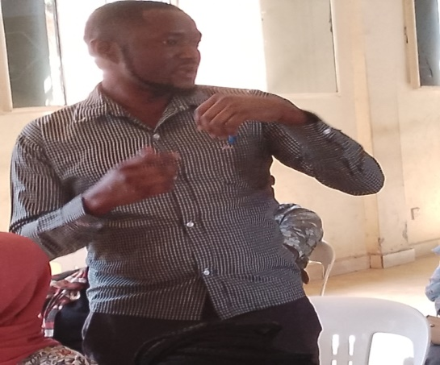  A participant demonstrating a point during the training

Participants of the training

The training was attended by 30 participants (21 females and 9 males). Refugee community was represented by 18 participants (11 females and 7 males). These refugees were from Somalia (3), Sudan (3), Congo (6), Burundi (2) and Rwanda (4). All the participants were representatives of community based organisations. Each of these participant represented 3- 4 groups. In fact each was supposed to work with these groups. The participants’ representation is shown in the summary table that follows:

Nationality | Female | Male | Total
Burundians | 1 | 1 | 2
Congolese | 5 | 1 | 6
Rwandese | 3 | 1 | 4
Somali | 0 | 3 | 3
Sudanese | 2 | 1 | 3
Ugandans | 10 | 2 | 12
 | 21 | 9 | 30

Opening Session

The training started with prayers led by a volunteer. This was followed by participants’ self-introduction and PLAVU programs Manager introducing the organization and objectives of the training.

Session 1: Deepening understanding of the groups, organisations we belong in

Andrew [PLAVU] asked the participants to respond to the following questions:
  - What are the names of the 3-4- groups you represent?
  - When did the groups start?
  - What is their vision? Mission?
  - What systems and structures do they have?
  - How many members do they have? How many are females and males? How many are refugees?
  - What activities do they do? Why?
  - What projects are being implemented? If none say so. Why?

The above questions proved difficult for all participants. This is because none of the trainee prepared enough to have a deeper understanding of the groups they were representing. Besides that only 1 out of 10 participants could explain the details concerning their own organization. This means that 9 out of 10 organisations represented here were not organised well. In other words, they did not have structured organisations with well spelled systems, and visions. Each was asked respond to those questions when they returned back home after the training.

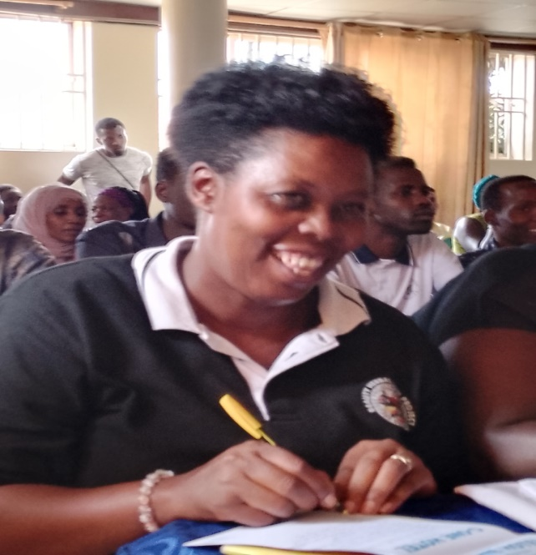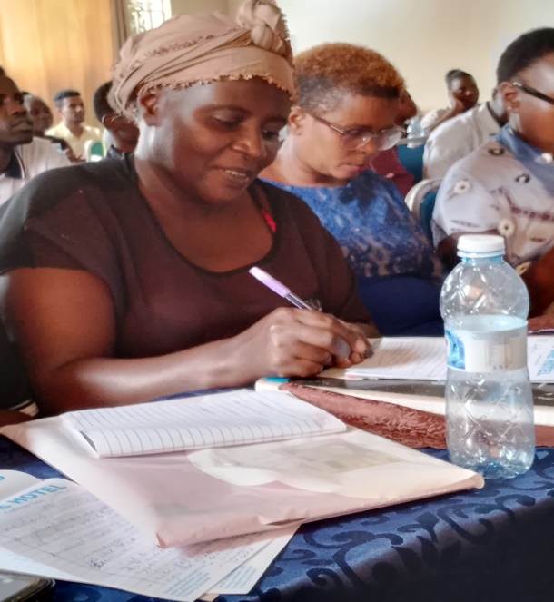
Female participants during the training

Session 2: Understanding the Concept Community Based Organisations/Associations

Through a brainstorming exercise, the participants were asked to explain their understanding the concept Community Based Organisation (CBO), the 5 most important functions of CBO and the most important characters of a CBO leader.
Information from the participants showed that they were clear of what the concept CBO mean. This is illustrated in the voices that follow:
A CBO is….

“a group of people living together in the same village with a target to fulfill” According to a female refugee from Rwanda

“a group of individuals who are 15 to 50 with set activities and aim to help the communities or support the community” a male host community member said.

“a group of people operating within a sub-county to improve the livelihood of the people” said a female participant.

According to the participants these are the most important functions of CBOs

- Improve community members
- Lift up the community
- Support government
- Promotes skills of the members

The most important characters of CBO leader:
- Enables people to come together and solve their problems
- Must be literate
- A good communicator
- Faithful
- Must be patient
- A good listener
- Good time management
- Must be exemplary
- Keeps law and order
- Must be social

The facilitator then shared notes. He promised that handouts shall be shared later.
He said that a Community Based Organisations (CBOs) are local not-for-profit groups, organisations and or associations which work to generate improvements within a community on the local level. CBOs are driven mainly by private individuals from the relevant community. They are able to seek financial, material and social assistance from other institutions and agencies. They aim at improving the community’s wellbeing.
He further noted that leaders of CBOs must have the capacity to plan and envision, fundraise, document, account and mobilise members and partners. Associations and RLOs are CBOs provided they operate at a lower local level. CBOs can be registered or unregistered. However, in order to attract support and for legal recognition, registration is inevitable.

Session 3: Understanding Organisational Structures, Systems and functions of KCCA/Duties of citizens

Participants were organise in 2 groups to respond to the questions:

Group 1

  - What are the characteristics of a good group or association?
  - What are the challenges to putting together group systems and structures?
  - What should we do to make our groups effective

Group 2

- What are the functions of KCCA in our areas?
- What do we benefit from KCCA?
- What are the duties and responsibilities of citizens and refugees?

After group discussions (which lasted 30 minutes), the participants presented in a plenary.

Group 1
Characteristics of a good group

- Good leadership
- It must be registered
- Has a management committee
- Has a constitution
- Keeps record of events
- Members able to share ideas and information
- Disciplined and respectful
- Members work in teams
- Able to convene meetings
- Has a vision and mission
- Time management and is accountable

Challenges to putting together systems and structures

- Poor leadership
- Undisciplined members
- Not convening meetings
- Poor communication, language barrier and misunderstandings
- Lack of trust
- Corruption and embezzlement
- Inadequate lobbying
- Lack of confidentiality
- Internal wrangles
- Self-centeredness

What needs to be done to make groups effective?

- Regular information sharing among members
- Conduct regular meetings
- Encourage transparency
- Motivate leaders and members
- Manage time well
- Increase productivity of the group
- Lobby for funds for the group

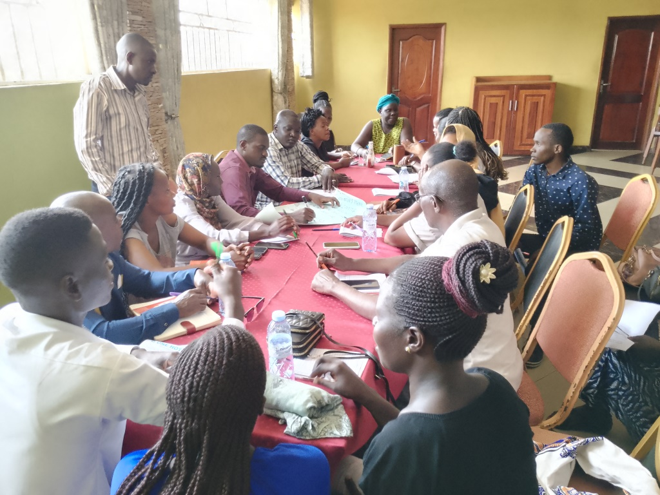
Group members comprising of Makindye and Nakawa representatives

The facilitator then shared some notes.
According to the facilitator, organizational structure is a framework around which the group is organized, the underpinnings which keep the coalition functioning e.g. selection of leaders. The examples of structures are:
- Constitution or Memorandum of Understanding or Articles of Association
- Strategic Plan
- Membership policy and registry
- Organisational focus; Vision, Mission, Location
- Leadership structures; BOD, Steering Committee, Secretariat or Coordination Committee
In summary, an organizational structure ensures that the organization will function smoothly and as you intended it to be.

Functions of a group/association

- Address the issues of the marginalized groups
- Promotes participation and voice of the marginalised
- Improves wellbeing
- Creates awareness
- Advocates for the poor and marginalized
- Promotes accountability of service providers- question
- Builds the capacity and empowers the marginalized groups

Functions and roles of a group/association leader

- Must be accountable
- Should be a communicator
- A planner
- A mobiliser
- Fundraiser
- Builds the capacity of others and prepares new leaders
- A listener to everyone
- Sets long and short term goals of the organization
- Be an inspiration e.g. collects garbage in the community
- Committed, Courageous and creative

In summary a leader “makes a difference”

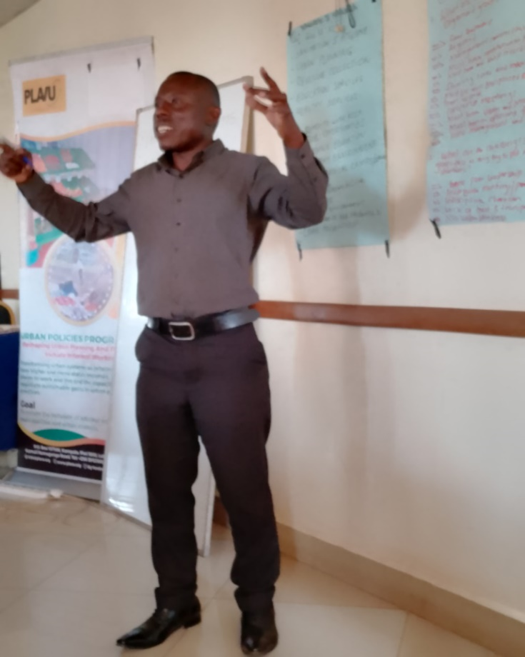
Mr. Kivumbi stressing a point during the training

The facilitator shared the story of a young boy who was touched by a problem and initiated to address it.

“When John, a 4 years old boy saw a news report about starving children in his community she felt touched and decided to act. At five, with his grandmother at her side, she went knocking on doors asking for food donations for poor people in her community. When she was six years, he collected 1,600 items to give to people in need. The following year, she collected 4,000 items. Later his grandmother suggested he start an association. With the help of his grandmother and a lawyer he established the FOOD FOR ALL ASSOCIATION (He was only 8 years)”.

The story became an inspiration to the participants. Some mentioned the following lessons from the story:
“The story taught me not to undermine self. It shows that one can start with whatever small that is available” revealed a female refugee from Rubaga

“Story shows that all communities have issues and challenges but the solutions starts with you” remarked a male refugee host community member from Makindye

“Story shows that we are a voice for others” said another female participant

“We are stronger together. Story shows the power of the voice” remarked another female participant

Plenary discussion from Group 2
The roles of KCCA in our areas

KCCA is responsible for;

- Sanitation and hygiene
- Urban planning
- Revenue collection
- Education services
- Health services

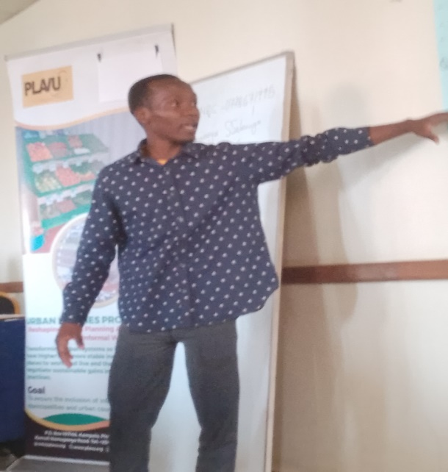
Mr. Mukalazi a male participant from Makindye

Benefits from KCCA

- Job opportunities
- Affordable education services
- Environmental health management
- Free medical camps

Duties and responsibilities of citizens/refugees

- Payment of taxes
- Preserve the environment
- Take care of our household members
- Prevent crimes

At the end of the plenary, the facilitator (PLAVU PM) shared the following notes:

Functions of the City Councils

- Initiate and formulate policy and ordinances;
- Set service delivery standards;
- Undertake planning and budgeting for the city
- Determine and enforce tax collection and business licenses;
- Deliver, manage and monitor service delivery (roads, education, markets, water, drainages, street lights; physical planning, poverty eradication programmes)
- Maintenance of law, order and security;

Functions of the City Councils

- Initiate and formulate policy and ordinances;
- Set service delivery standards;
- Undertake planning and budgeting for the city
- Determine and enforce tax collection and business licenses;
- Deliver, manage and monitor service delivery (roads, education, markets, water, drainages, street lights; physical planning, poverty eradication programmes)
- Maintenance of law, order and security;

Session 4: Understanding the concept Advocacy

According to the participants, “advocacy involved laws and policies”, “okutuusa eddobozi” literally meaning; “to voice out”. Another participant mentioned that advocacy is “talking on behalf of the vulnerable and voiceless”.

According to the facilitator, “Advocacy” is an activity by an individual or group that aims to influence decisions within political, economic and social institutions. Advocacy includes activities and publications to influence public policy, laws and budgets by using facts or evidence, their relationships, the media, and messaging to educate government officials and the public.

Advocacy strategies and approaches include:

- Policy monitoring and public accountability- CSBAG budget analysis and engagement
- Policy dialogue
- Campaigns for policy change

Planning for an advocacy activity

- Identify the problems and the policy issues
- Defining the advocacy goal
- Building relationships
- Analyse the policy environment- relevant policies, laws and regulations, Mapping power and decision making relationships
- Considering the options for policy change
- Developing the strategy
- Identifying the target audiences, allies and opponents
- Selecting the advocacy approach
- Develop key advocacy messages

8.0. Session 5: Action planning

The participants were asked to form division based groups and discuss the next steps by drawing a work-plan considering the following:
  - The need to pass on information achieved from this training to other members
  - An advocacy issue relevant in their area
  - The gaps relevant in the groups and associations of the participants

Central Division Group
Issues for advocacy
- Insecurity
- Access to health services
- Challenges faced by street vendors (harassment from KCCA)
- Poor roads
- High costs of primary education
Although the work-plan was drawn, it had several gaps (many areas needed clarity). The team was therefore asked to further improve the work-plan

Makindye Division
Advocacy issues
- Poor quality government primary schools
- Access to quality services in KCCA health facility
- Kisasizi lacks public sanitation facilities
- High level of unemployment
- High rent costs
The team agreed that they would go back:
- Convene a meeting to share information with other members
- Discuss with other members to identify problems to be addressed through advocacy

Rubaga Division
Issues for advocacy

- Access to public medical facilities & lack of drugs
- Shortage of public education facilities
- Poor roads

The team agrees to do the following:
- Organise community meetings
- Train leaders of the groups
- Advocate for the issues identified

Nakawa Division

Issues for advocacy

- Insecurity
- Poor sanitation
- Unemployment
- Poor roads
- Poor health services at Naguru health facility
- High primary school drop out

The team agreed to go back and develop a detailed plan of action.

Next steps

The program Manager thanked the participants for attending and asked them to go back, fill the registration forms of all the members of the groups, pass on the information and prepare to work with PLAVU. He informed them that an agreement and information templates shall be shared. We hope to begin work the following month of April 2023.

Attendance list

No | Name | Sex | Group Name | Division | Nationality | Contacts
1 | Habimana Gerald | M | Rema Group 49 Members | Lubaga | Burundian | 0770 943449
2 | Kavitesi Florence | F | Women Building Nation Refugee Group | Lubaga | Burundian | 0757 433573
3 | Samantha Samba | F | Bright Women | Makindye | Congo | 0709 689560
4 | Clovis Mugenyi | M | Angels Fashion devt Group | Makindye | Congo | 0761 140275
5 | Vestarade Asmahan | F | Light Social Innitiative | Makindye | Congo | 0702 089571
6 | Bamulange Odile | F | La Grace Group | Lubaga | Congo | 0781 330497
7 | Igabire Prossy | F | Namugoona Youth bags & leater crafts | Lubaga | Congo | 0777 605341
8 | Uwineza Sulaina | F | Faith Development Group | Lubaga | Congo | 0774 209801
9 | Agnes Mulamugena | F | Agape Refugee Foundation | Lubaga | Rwanda | 0701 885864
10 | Appolon Mukakamali | F | Refugee Womens Development Group | Lubaga | Rwanda | 0785 463322
11 | Uwineza Saddick | F | Charity Development Group | Lubaga | Rwanda | 0708 606309
12 | Kabalega Andrew | M | Urunana Community Savings Group | Lubaga | Rwanda | 0780 153448
13 | Nayma Awale Hisi | M | Muno Nuir Saving Group | Central | Somali | 0776 629056
14 | Mohamed Hassan Abdalkadir | M | Somali Community Association | Central | Somali | 0758 526800
15 | Dhaah Ali Hashi | M | Aidar Refugee Group | Central | Somali | 0744 507177
16 | Fatuma Njundi Sulaina | F | Blue Nile youth Development Group | Makindye | Sudanese | 0789 939209
17 | Hajir Elbadani | M | Mantairs sudanese community in K'la | Makindye | Sudanese | 0773 366677
18 | Adam Ahmed Abdallah | F | Makerere | Central | Sudanese | 0774 303869
19 | Anek Agnes Odong | F | Kabalagala Kiwaffu Women Devt Group | Makindye | Ugandan | 0789 390585
20 | Katutu Betty | F | Mukama wa Buyinza Womens Group | Makindye | Ugandan | 0776 585096
21 | Nanyango Sarah | F | Kwagalana Devt Group | Makindye | Ugandan | 0704 660597
22 | kaddu Justine | F | Hope Family Savings Group | Central | Ugandan | 0706 700682
23 | Mawilak Gloria | F | Naguru women savings Group | Nakawa | Ugandan | 0766 156680
24 | Babirye Rose | F | Tuyinza Saving Sacco | Central | Ugandan | 0753 482184
25 | Mbabazi Winnie | F | Toto Business Group | Lubaga | Ugandan | 0701 226099
26 | Kakooza Prossy | F | Kabalagala Critical Thonkers | Makindye | Ugandan | 0772 949254
27 | Nakagwe Agnes Mirembe | F | Twezimbe Savings Gropu | Makindye | Ugandan | 0760 383229
28 | Mukalazi Abdulrahman | F | Right Hand of Uganda devt Group | Makindye | Ugandan | 0757 101933
29 | Okuku Frank | M | Kabalagala Critical Thonkers | Makindye | Ugandan | 0773 041419
30 | Vincent Sseguya | M | Nyago Local Council Leader | Makindye | Ugandan

